



EKM - 40
VERTICAL CONVEYOR TOASTER
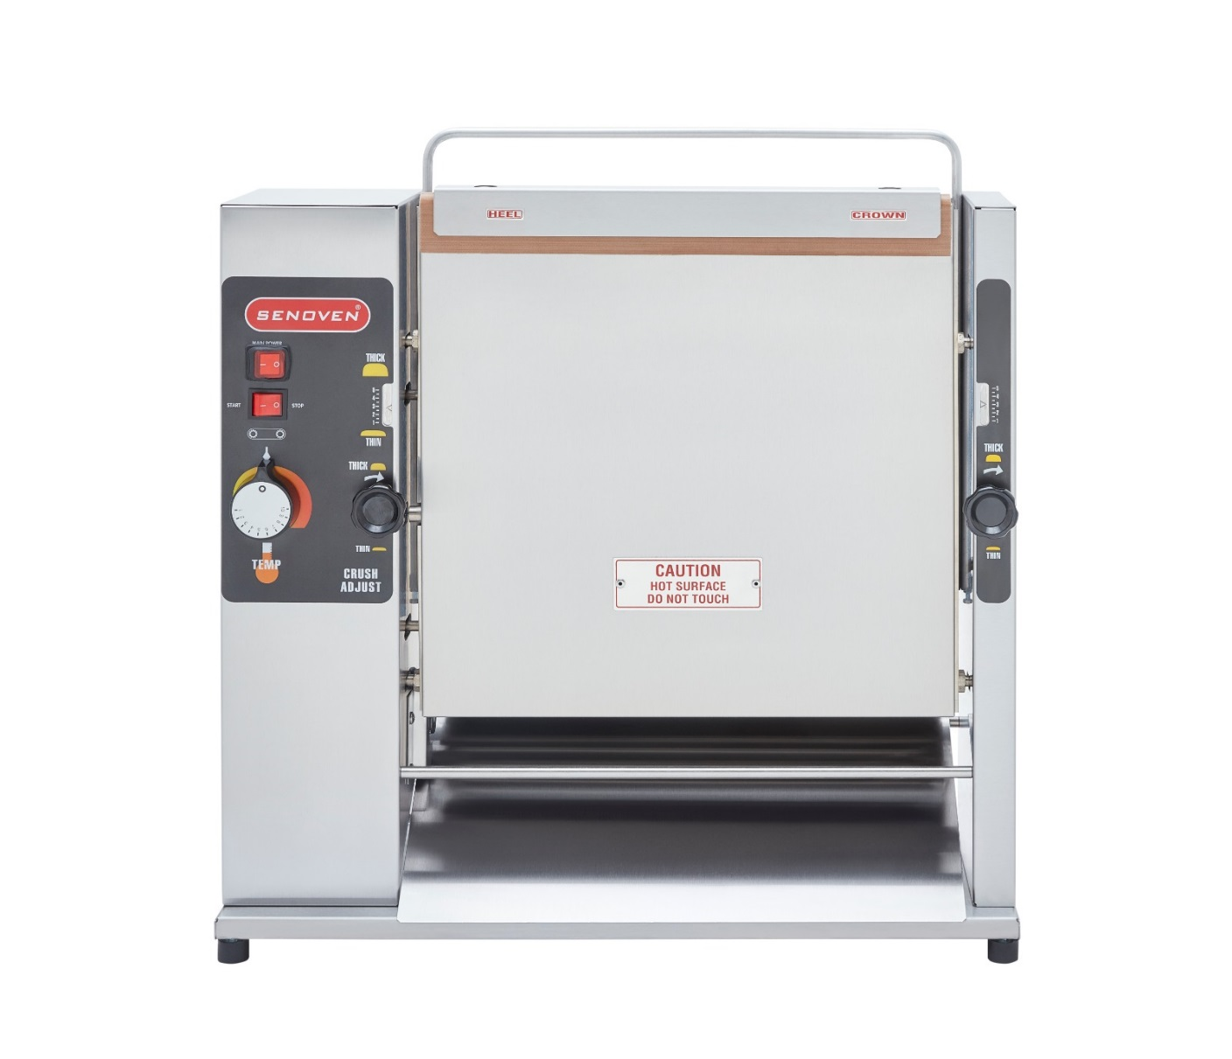

USAGE AND MAINTENANCE MANUAL

MANUFACTURER COMPANY: ŞENGÜN MAKİNA İNŞAAT VE KIRTASİYE SAN. TİC. LTD. ŞTİ


WARRANTY CERTIFICATE

SERIAL NUMBER:
SALE DATE:
Sold at the above date EKM - 40 MODEL VERTICAL CONVEYOR TOASTER is guaranteed against production failures for 1 Year by ŞENGÜN MAKİNA İNŞAAT and KIRTASİYE SAN. TİC. LTD. ŞTİ.

Warranty Terms;
- Warranty terms start after the product delivery for 1 year.
- Recommended daily working time is 10 hours. The scope of warranty is assessed by year or by working hours.
- The product is under warranty except plastic rollers (included plastic rollers if it is a manufacturing defect).
- Documents are invalid, if haven’t sale date and confirm signature of company. You have to show the warranty certificate to benefit from the warranty.
- Device is guaranteed against defects if mount and use as described ın the use and maintenance manual.
- Detection the location of defects, and elimination of the problems are responsibilities of the ŞENGÜN MAKİNA…
- Warranty terms includes only one device. You can’t claim any rights or compensation for another devices.
- If Changes are made at the type, model and serial numbers, the warranty eliminates.
- If material, worker or assembly defects appear, repaired free by ŞENGÜN MAKİNA at the product warranty period (Transportation cost is not included).
- Failures are only repaired by ŞENGÜN MAKİNA’s personal. The intervention of unauthorized person, cancel the appliance of warranty.
- Installation have to be done by ŞENGÜN MAKİNA’s personal. İf usage place changes, customer must give information to ŞENGÜN MAKİNA
- In the event of failure service must be informed.
- The failures and damages given by external factors are out of the warranty terms.
- Any failure of the product warranty period is added to the product warranty time. The repair time is until 20 working days.
AUTHORIZED PERSON

STAMP –SIGNATURE

PRESENTATION

Dear Users,

Thank you for your prefer our machine and condifidence in our company .Our machines are used in 39 countries.

Our machine is manufactured according to international standards. Please read the operating manual to get the mast out of your machine .Please note the following warnings before calling our service.

ŞENGÜN MAKİNA

- Please read the manual carefully before installing the machine.
- The machine will be out of warranty when your operate the machine with at read.
- Please read carefully the manual that gives you information on the installation is prepared in accordance with the legal regulations before arriving at the machine installation.
- For information you cannot understand, ask your nearest authorized service.
- Please note that if the technical service personnel is kept waiting you will be billed for each hour.

CONTENTS

SECTION 1: Introduction
  - Vertical Conveyor Toaster General Description
  - Technical Specifications Table

SECTION 2: Installation

2.1 Installation Instructions

2.2 Operating

2.3 Optionally

SECTION 3: Cleanıng

3.1 Cleanıng Instructıons
3.2 Preventive Maintenance

SECTION 4: Troubleshooting
4.1 Failure Detection

SECTION 5: Machine Spare Parts
5.1 Front View
5.2 Conveyor Installation
5.3 Back View
5.4 Internal Components

SECTION 6: Electrical Diagram

6.1 Connection Diagram

SECTION 1: INTRODUCTION

1.Vertical Conveyor Toaster
General Description:
Vertical Conveyor Toaster provides excellent caramelisation with contact frying. Unique two level heat plate design allows operators to fry thicker or thinner bread at the same time.

  - Technical Specifications

Model Numarası | Width (mm) | Heigh (mm) | Depth (mm) | Weight (kg) | Crown Max.Bread Height (cm) | Heel Max.Bread  Height(cm) | Bread Exit Time | Max. Bread Diameter
EKM-40 | 635 | 664 | 203 | 37,2 | 4 | 3 | 20 sn. | Ø20 cm

Output & Electricity

Model Number | Explanation | Output | Volt | Hz | Watt | Amps
EKM-40 | VERTICAL CONVEYOR TOASTER | 1400 | 230 | 50-60 | 1700 | 7,5

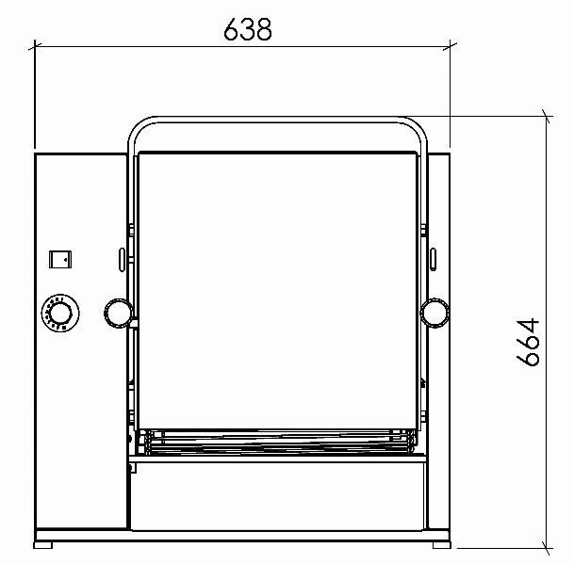
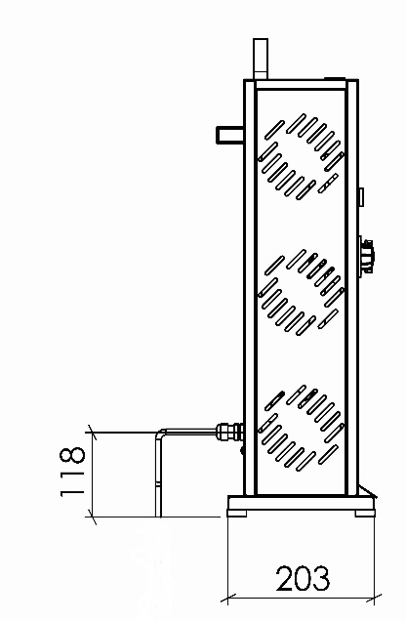
635

SECTION 2: INSTALLATION

2.1 Installation Instructions

- After removing the Vertical Conveyor Toaster from its packaging, inspect the unit for signs of damage. If damaged in the unit:

- Hide packaging materials.
- Contact the manufacturer or the company where you purchased the machine.
- Verify that all parts have been received

- Vertical Conveyor Toaster conveyor installation:

- Crumb tray is connected to the front side of the conveyor.
- Place Vertical Conveyor Toaster on flat surface. Remove the protective covering.
- Install the teflon layer on the heat plate.

- Lift conveyor off conveyor guide rails and set aside.

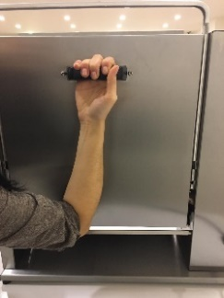

Conveyor Guides

- Place the Teflon sheet on the heater plate, make sure there is a 75 mm overhang.

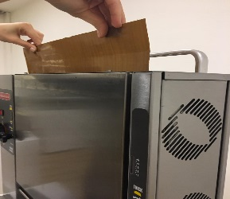
75 mm Overhang

Teflon Cloth

- Place the compression sheet and the Teflon gland together on the heat plate.

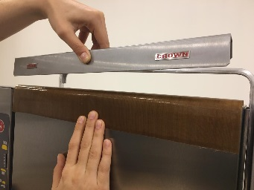
Compression Sheet

- Attach the conveyor to the conveyor Vertical Conveyor Toaster by passing through the guide rails. Ensure that the conveyor socket is firmly seated.

- Hang the back end of the crumb tray on the bar under the conveyor group.

- Plug unit into a grounded receptable.

  - Operating

- Turn the main power switch to the ‘‘On’’ position. Allow 30 minutes for heat plate to reach operating temperature.
- Press the Conveyor Start-Stop button under the main power switch to move Conveyor Belt.

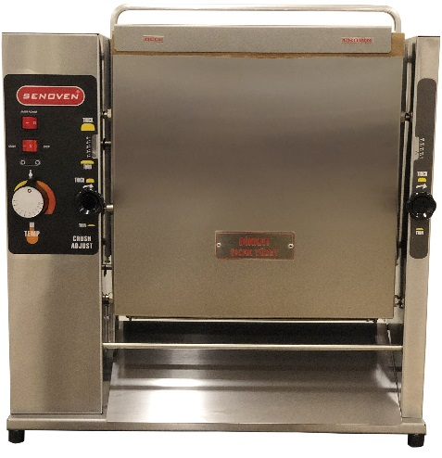
Main Power Switch

Conveyor (Belt) Start-Stop Button

- Place a sample product on the top of the conveyor casing. The side to be toasted should face the heat plate.

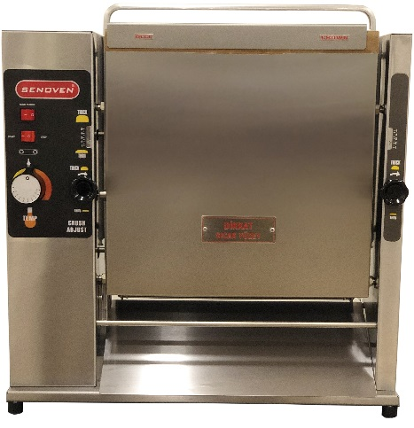

- The toasted product will be sent automatically from the bottom of the conveyor.

- Verify that product meets acceptable standards. If not, see adjustment section.

- The Vertical Conveyor Toaster can be adjusted to provide the necessary compression for various products.

- Turn the two roller adjustment buttons clockwise for thicker products. Turn the two roller adjustment knob counterclockwise for fine products.

- Numbers setting will indicate 1 for thinnest product, 5 for thickest.

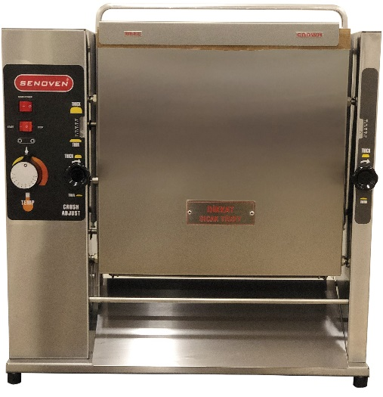

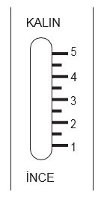
Thermostat Knob

THICKER

THINNER

Platen Adjustment Knobs

- The temperature oh the platen can be adjusted to compensate for darker or lighter frying requirements. Turn the thermostat adjustment knob clockwise for more frying. Turn the thermostat adjustment knob counterclockwise for lighter frying.

IMPORTANT: After adjusting the thermostat, wait for 15 minutes to stabilize the level of the toaster.

2.3 Optionally

The gear set on the machine is designed to rotate the conveyor band up to 2 round/min. If the conveyor belt speeds are wanted to be increased please contact the seller.

Conveyor and Engine Gears

There will be a 0.3 mm clearance between the conveyor and the motor gear when properly aligned.
Incorrect alignment cause the is conveyor to jam periodically.

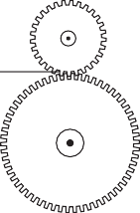

0.3 mm Space
Teeth be
Properly
Mesh

True False

Tools Needed: 2.5 Allen Wrench
- Working from the “back side” of the bread frying machine, loosen the 2 set screws at the bottom of the conveyor guide until the conveyor stops. Note: The conveyor assembly may need to be removed for easier access.

- Attach the set screw to the conveyor belt, and use a hexagonal wrench to tighten them.

M5 Hexagonal
Set screw
M5 Counter
Nut

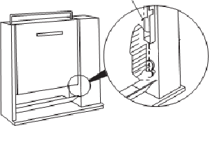
8 ‘ hex head key

- Tighten the set screw until the top of the conveyor housing is parallel to the base of the machine.

- Carefully tighten the set screw to 1/2 turn until parallelism is achieved.

- Remove the conveyor assembly.

- Apply a drop of lubrication to both set screws.

- Replace the conveyor assembly.

SECTION 3: CLEANING


ATTENTION: Water should not be cleaned by spraying.

ATTENTION: Do not dive in water.

3.1 Cleaning Instructions

- Turn off the main power switch and remove the conveyor.

- Allow the conveyor to cool for 60 minutes before cleaning.

- Remove the conveyor assembly.

- Wipe the conveyor with a damp cloth. Use a soft brush for the chain.

- Remove the inner sheet from the conveyor and place it on a flat surface. Clean all residues. Clean both sides of the sheet with a damp cloth and allow to dry.

IMPORTANT: Turn the teflon diaper twice a day for longer life. The Teflon cloth should be changed according to daily usage in a period of 4-6 months on average.

- Use a damp cloth to remove residues on the conveyor.
IMPORTANT: Do not use sharp objects, hard wire brushes, dishwashing wires or abrasive cleaners on the plate. Otherwise, irreparable damage may occur.

3.2 Preventive Maintenance
To extend the life of your engine, you have filled the shaft of the engine with 2-3 drops of oil every 3,000 hours.
Shaft

IMPORTANT: Before doing any protective maintenance, unplug the bread frying machine.

SECTION 4: TROUBLESHOOTING

4.1 Failure Detection

PROBLEM | PROBABLE CAUSE | SOLUTION
Unit ıs not heating.  Main power switch outdoor.  The light is not on. | No power in the unit.  The main power cord is faulty.  There is loose connection in the main power switch. | Make sure the power cord is connected to the appropriate slot and power input. Replace the power cord. Tighten the main power switch connections. Change the main power switch.
Unit doesn't warm up.  Main power switch on.  The light is not on. | The thermostat is malfunctioning.  Conveyor rotation shaft is not working. The power switch is faulty. | Change the thermostat.  Replace the conveyor rotation spindle.
The unit is warming up, but the conveyor is not running. | The engine key is loosely connected. Faulty motor. Driven gears are worn out.  The chain gear are loose.  Engine key. | Tighten the engine key connection. Replace the engine. Replace the drive gear. Adjust and tighten gears. Set conveyor detecting screws squeeze (see conveyor and engine gears on page 8). Change the key.
The unit overheats more or less (Thermostat does not function). | Thermostat malfunction. | Change the thermostat.
Bread does not blush | Check the plate temperature..  (see section 2.2) | Adjust the print plate for proper compression.  Adjust the thermostat at the appropriate temperature.

SECTION 5: MACHINE SPARE PARTS

5.1 Front View

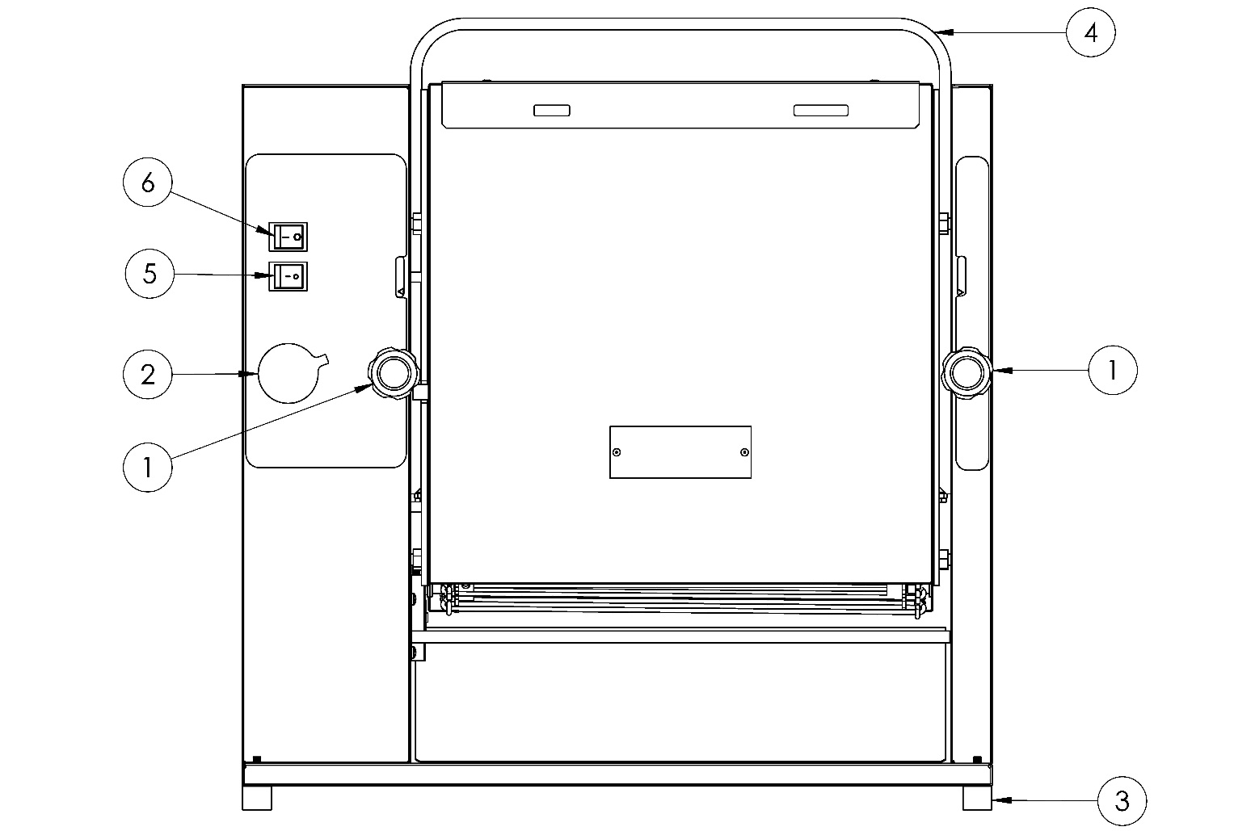

ITEM | SPARE PARTS NUMBER | SPARE PARTS DESCRIPTION | UNIT
1 | 05057 | PLATEN ADJUSTMENT KNOB | 2
2 | 05073 | THERMOSTAT ADJUSTING WHEEL | 1
3 | 05064 | FOOT | 4
4 | 05046 | JOINING SHEET | 1
5 | 05000 | BUTON | 1
6 | 08091 | BUTON | 1

5.2 Conveyor Installatıon

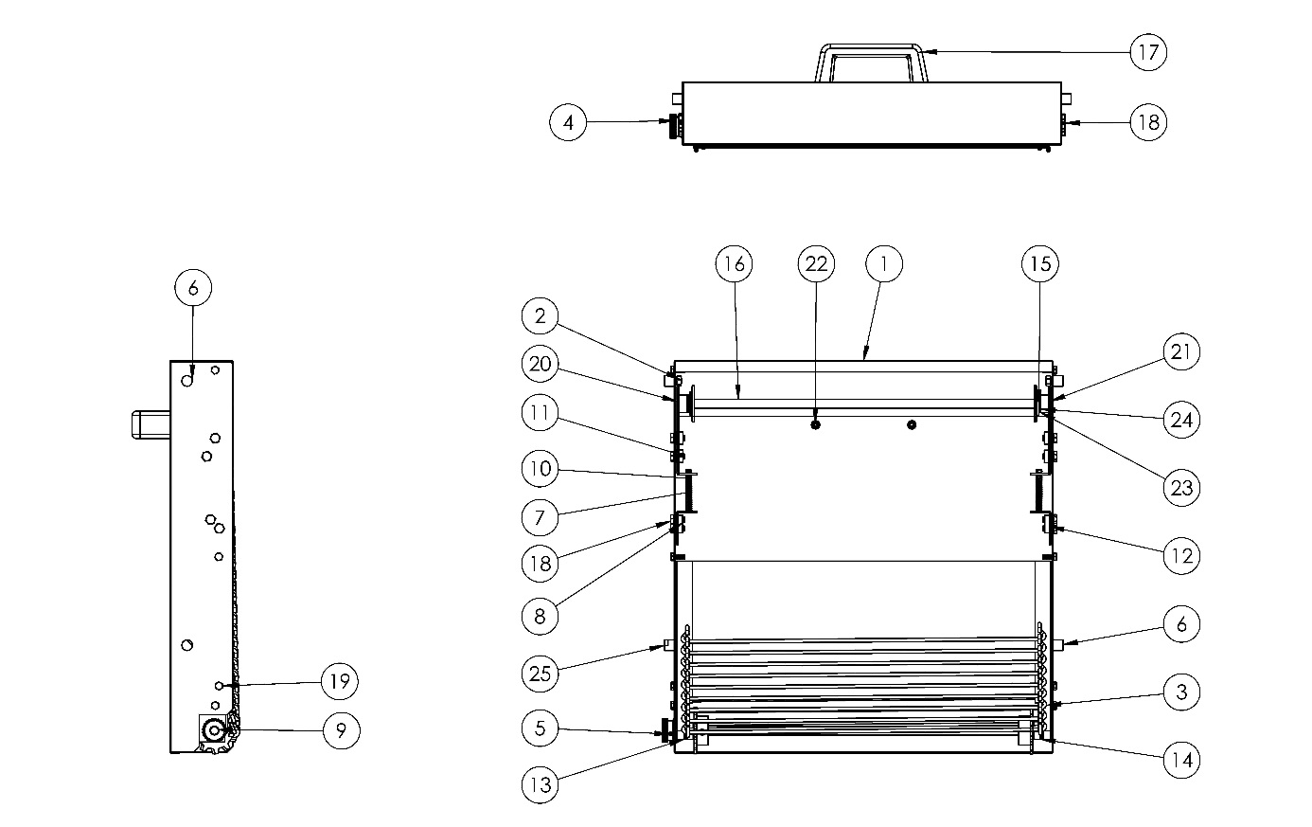

00287M SPARE PARTS LIST
ITEM | SPARE PARTS NUMBER | SPARE PARTS DESCRIPTION |  | UNIT |  | ITEM | SPARE PARTS NUMBER | SPARE PARTS DESCRIPTION |  | UNIT
1 | 00288M | CONVEYOR BOX |  | 1 |  | 14 | 05016 | THIMBLE |  | 2
2 | 03086 | NUT |  | 4 |  | 15 | 05029 | WASHER |  | 3
3 | 00286M | WIRE BELT |  | 1 |  | 16 | 00283M | CONVEYOR SHAFT |  | 1
4 | 05059 | GEARWHEEL |  | 1 |  | 17 | 01549 | COVER WASHER |  | 1
5 | 05062 | SETSCREW |  | 1 |  | 18 | 01818 | BOLT |  | 8
6 | 05056 | BOLT |  | 3 |  | 19 | 01819 | BOLT |  | 8
7 | 00297M | SHAFT FIXING GROUP |  | 1 |  | 20 | 05031 | CONVEYOR SHAFT BEARING |  | 1
8 | 05060 | BEARING |  | 2 |  | 21 | 05032 | CONVEYOR SHAFT SHEET |  | 1
9 | 0299M | WIRE BELT SHAFT GROUP |  | 1 |  | 22 | 00340 | BOLT |  | 2
10 | 05055 | SPRING |  | 2 |  | 23 | 05069 | THIMBLE |  | 2
11 | 05042 | NUT |  | 4 |  | 24 | 05070 | THIMBLE |  | 2
12 | 00298M | SHAFT FIXING GROUP |  | 1 |  | 25 | 05087 | BOLT |  | 1
13 | 05035 | ALCOVE |  | 2

5.3 Back View
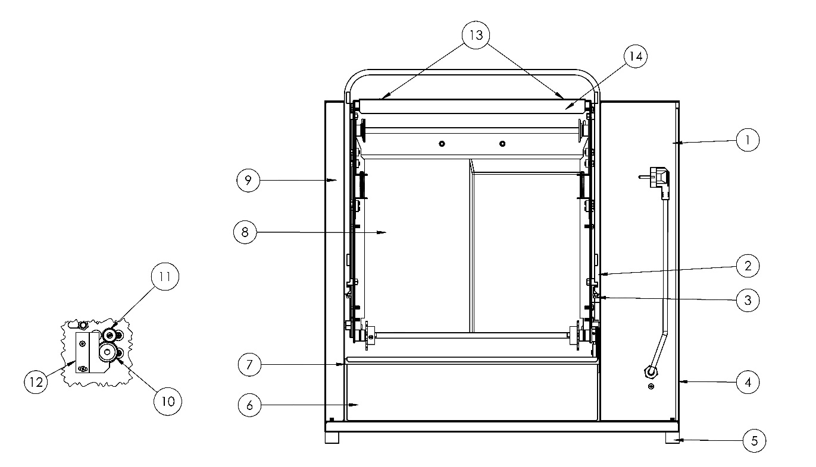

ITEM | SPARE PARTS NUMBER | SPARE PARTS DESCRIPTION | UNIT
1 | 05026 | CONTROL BOX | 1
2 | 05046 | JOINING SHEET | 1
3 | 04073 | BOLT | 2
4 | 05002 | SIDE COVER | 2
5 | 05064 | FOOT | 4
6 | 05005 | CRUMB TRAY | 1
7 | 05012 | CRUMB TRAY SUPPORT SHAFT | 2
8 | 00290M | RESİSTOR | 1
9 | 05014 | CONTROL BOX | 1
10 | 05067 | GEARWHEEL | 1
11 | 05059 | GEARWHEEL | 1
12 | 00287M | CONVEYOR BOX | 1
13 | 02342 | BOLT | 2
14 | 05004 | COMPRESSION SHEET | 1

5.4 Internal Components

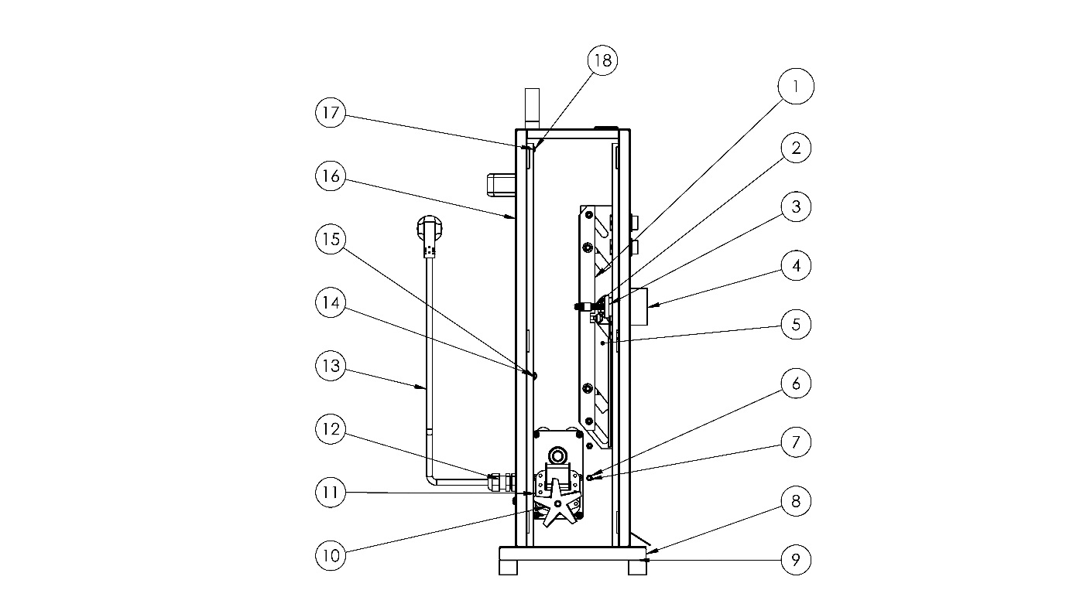

ITEM | SPARE PARTS NUMBER | SPARE PARTS DESCRIPTION | UNIT
1 | 05006 | CONVEYOR SUPPORT SHEET | 2
2 | 05058 | HOLDER SHAFT | 2
3 | 05088 | THERMOSTAT | 1
4 | 05073 | THERMOSTAT ADJUSTING WHEEL | 1
5 | 05030 | CONVEYOR SUPPORT SHEET | 1
6 | 00335 | FIX | 2
7 | 00046 | BOLT | 5
8 | 05025 | BASE SHEET | 1
9 | 00336 | FIX | 4
10 | 05082 | ENGINE PROPELLER | 1
11 | 05080 | CONVEYOR ENGINE | 1
12 | 00097 | RECORD | 1
13 | 00403 | POWER CORD | 1
14 | 05068 | PIN | 2
15 | 03086 | NUT | 2
16 | 05026 | CONTROL BOX | 1
17 | 02688 | BOLT | 2
18 | 00053 | NUT | 7

SECTION 6: ELECTRICAL DIAGRAM

6.1 Connection Diagram

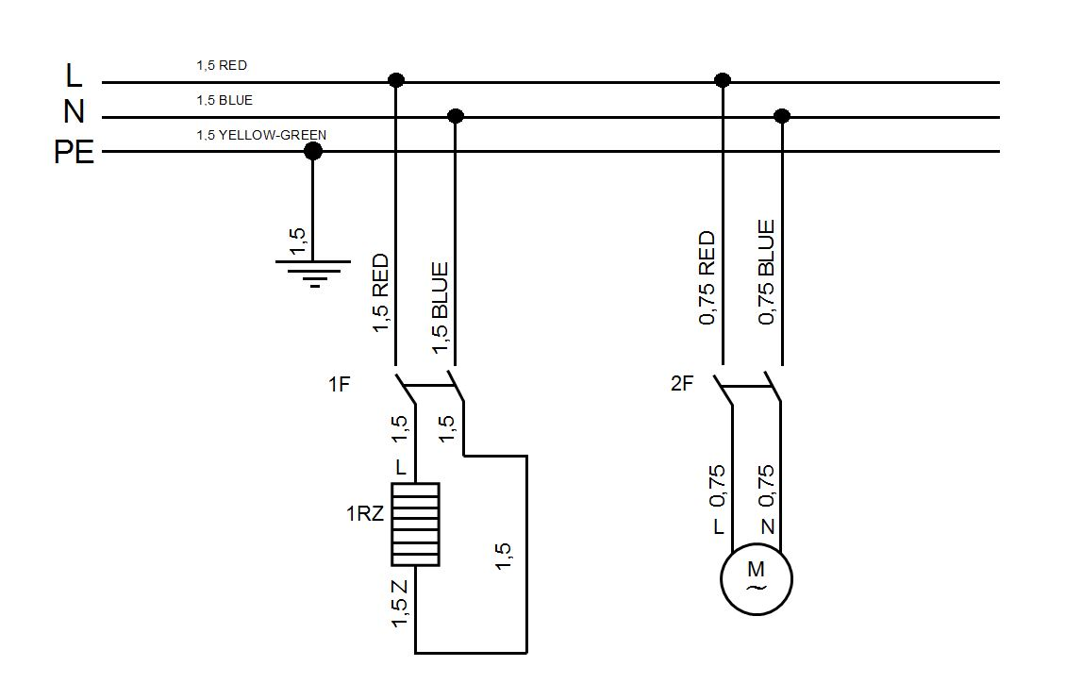



ŞENGÜN MAKİNA İNŞAAT VE KIRTASİYE SAN. TİC. LTD. ŞTİ.
İkitelli Organize Sanayi Bölgesi, Atatürk Bulvarı, Pufa İş Merkezi No: 98 Bodrum Kat: 2-3
Başakşehir/ İstanbul/ Türkiye

Phone: +90 212 671 23 23 (Pbx)
Phone 2: +90 212 671 84 84
Fax: +90 212 671 88 28
GSM: +90 533 957 14 53

e-Mail : info@sengunmakina.com
web : www.sengunmakina.com

